

2 Factor Authentication
User Manual

2 Factor Authentication Functionality 3
Feature Description 3
Settings 4
1. Placement 4
2. Two - Factor Authentication Configuration 4
2.1. Enabling 4
2.2. Setup 5
2.3. Enable Authentication with SMS 5
2.4. Modify registered number 7
2.5. Enable Authentication with App 7
2.6. Select Default method 9
3. Notifications 10
3.1. Enabling method confirmation 10
3.2. Disabling method confirmation 10
3.3. 2-Factor Authentication methods disabled 10
4. Disabling 2-Authentication methods 11
4.1. Disabling Authentication with SMS 11
4.2. Disabling Authentication with App 12
5. Problems signing in? Cannot authenticate option 13

2 Factor Authentication Functionality

Feature Description

The aim of this feature is to add an extra layer of security to each client´s account of Back Office. When enabling this functionality each time a user wants to log in to their account user name and password will be required and afterwards user will be asked to enter a code. This code will be sent through SMS or using an Authenticator App.

Settings

Placement

2-Factor Authentication will be located on the main menu of the Merchant > Settings > 2-Factor Authentication.

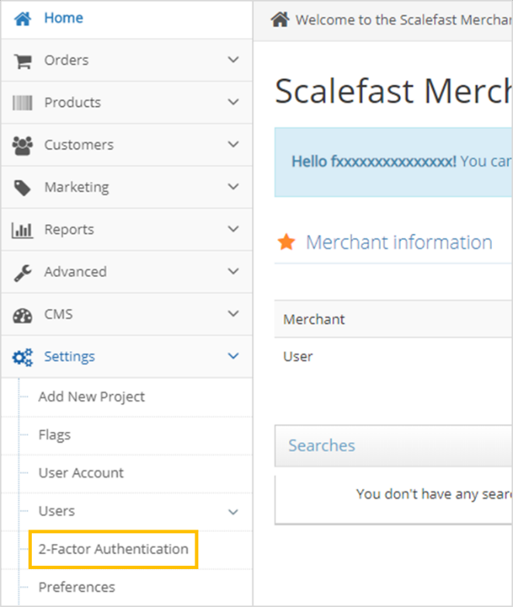

Two - Factor Authentication Configuration

When clicking on 2 - Factor Authentication, enable this option and configured desired level of security.

Enabling

Set the toggle button to YES

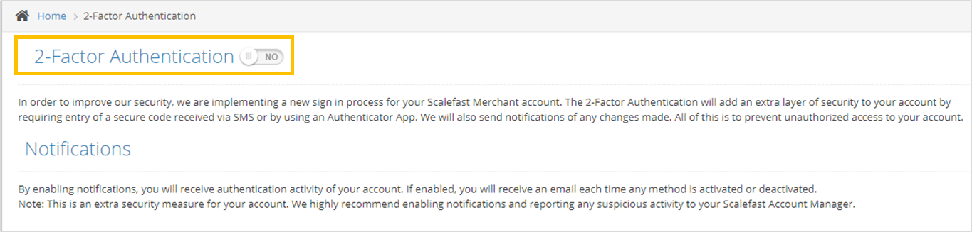

Setup

When toggle button is set to YES 2 options will be displayed, both toggle buttons will be set to NO by default:
- Authentication with SMS
- Authentication with App
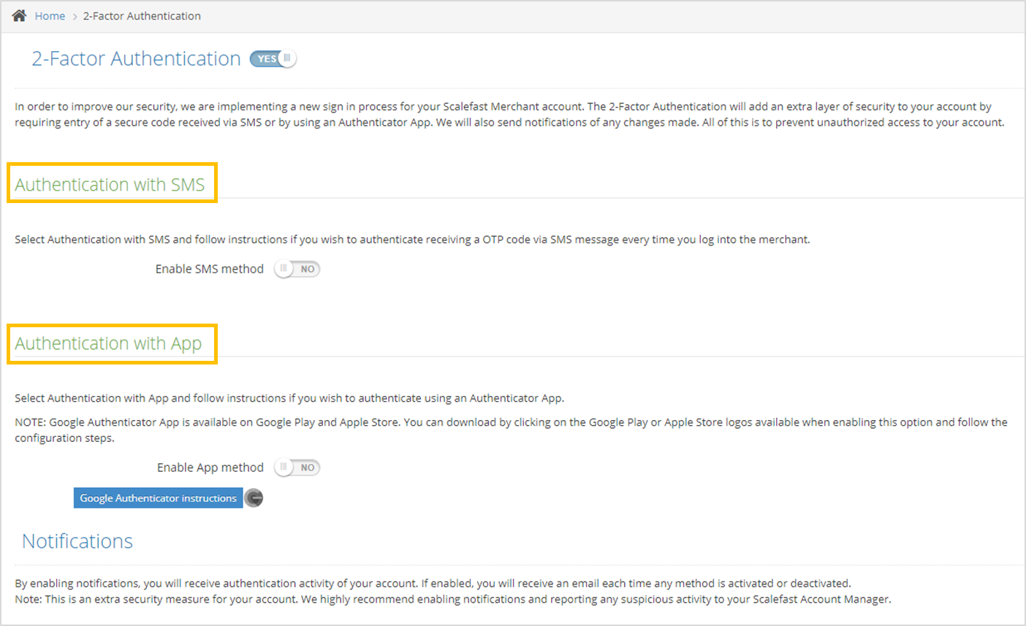

Enable Authentication with SMS

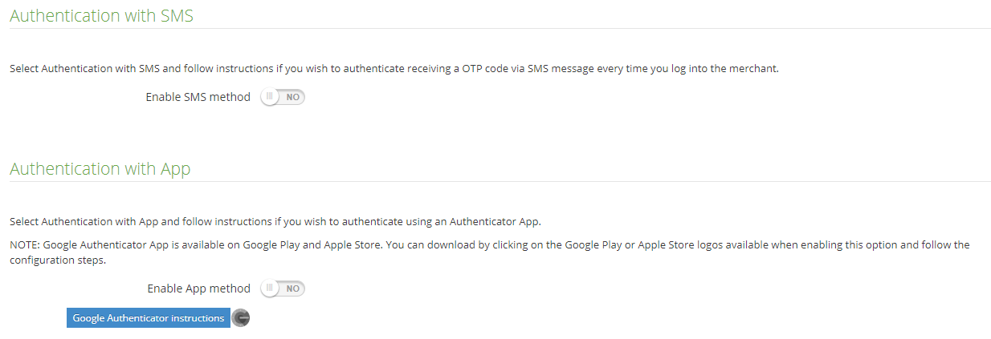

Enable Authentication with SMS by setting the toggle button to YES. A pop-up will appear.

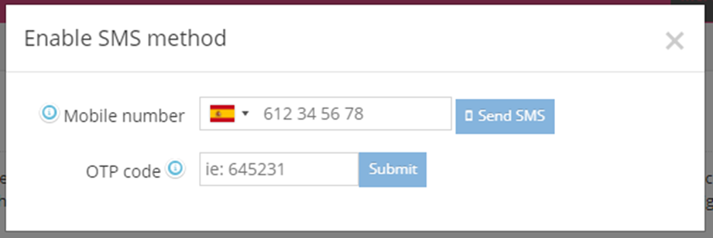

Select country code from the drop-down menu.

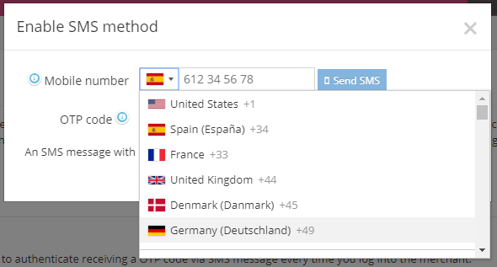

Enter the phone number and click Send SMS.

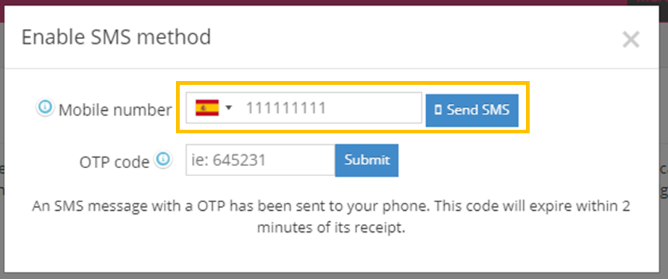

A code will be sent through an SMS, enter this code on the OTP code text box and click Submit.

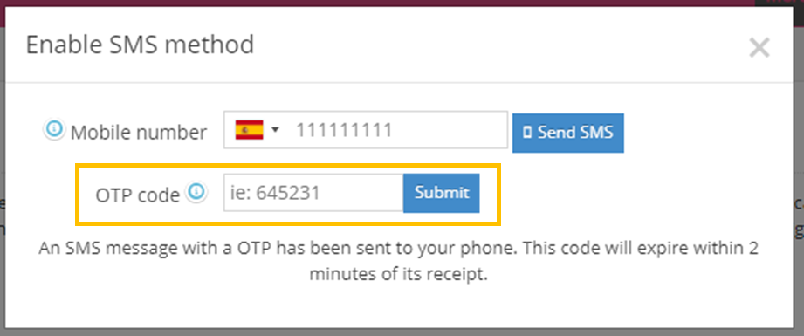

A pop-up will confirm the correct configuration.

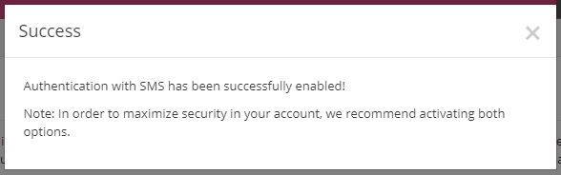

IMPORTANT INFORMATION:

- If no code was received please check that the number entered is correct and click Resend SMS.

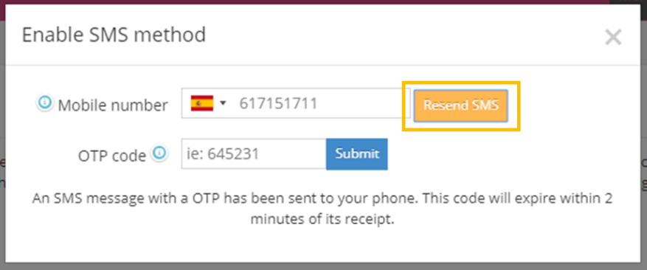

- Please note that codes only last for 2 minutes, if it wasn´t used during this period a new code must be requested.

- Sessions last for 3 minutes, during this period when logging out and logging in again you won´t be requested any Authentication code.

Modify registered number

If you wish to change the registered number, please disable Authentication with SMS and enable it again with the desired phone number by following the previous steps.

Enable Authentication with App

In order to be able to use the Authenticator with App, you must download the Google Authenticator App, both Google and Apple links will be available on the pop-up when enabling this option.

For information and instructions of use regarding the App please click on the blue link below the enable option.

Enable Authentication with App by setting the toggle button to YES. A pop-up will Appear.

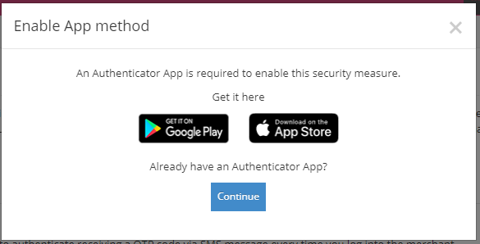

If you haven´t installed the App please go to your Google Play or Apple store to download it by clicking on the logos

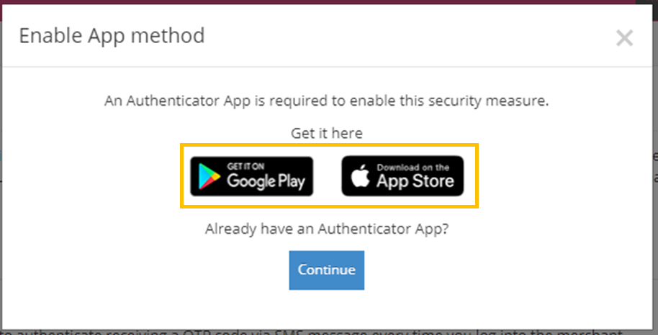

I you already have the App click on continue and scan the QR code to get the OTP code, enter the code and click submit.
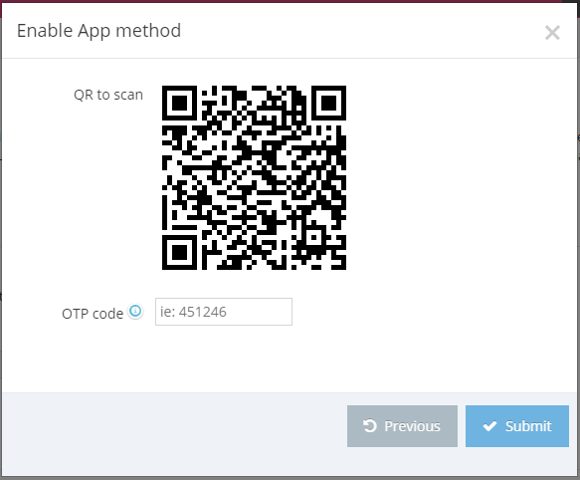

A pop-up will confirm the correct configuration.
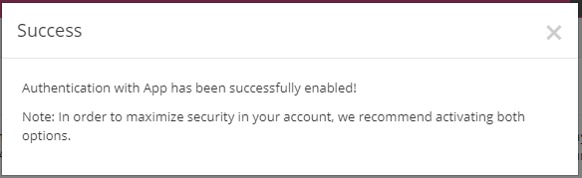

Select Default method

When enabling both options, users will have the option to choose which method will be used as the default method, this will be the one that will be used every time they want to log in to their account.
The other method will be used as a secondary authentication method.
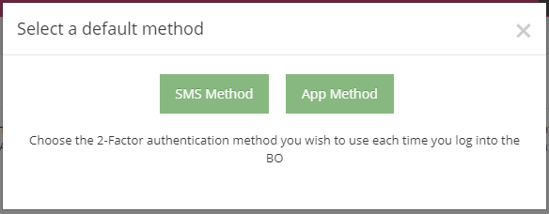

Notifications

As an additional security measure, notifications will be sent via email when enabling or disabling any of the 2-Factor Authentication methods.

Enabling method confirmation

When enabling any of the methods an email will be sent confirming the successful activation of the specific method, when enabling both methods 2 emails will be sent, one per method.

Disabling method confirmation

When disabling any of the methods an email will be sent confirming the successful deactivation of the specific method, when disabling both methods 2 emails will be sent, one per method.

2-Factor Authentication methods disabled

When using an emergency code all method will be disabled, therefore the user will receive an email notifying that the authentication has been disabled successfully.
NOTE: When enabling an Authentication Method Notifications will be automatically enabled. If you don´t wish to receive notifications regarding disabling activity, please set toggle button to NO.
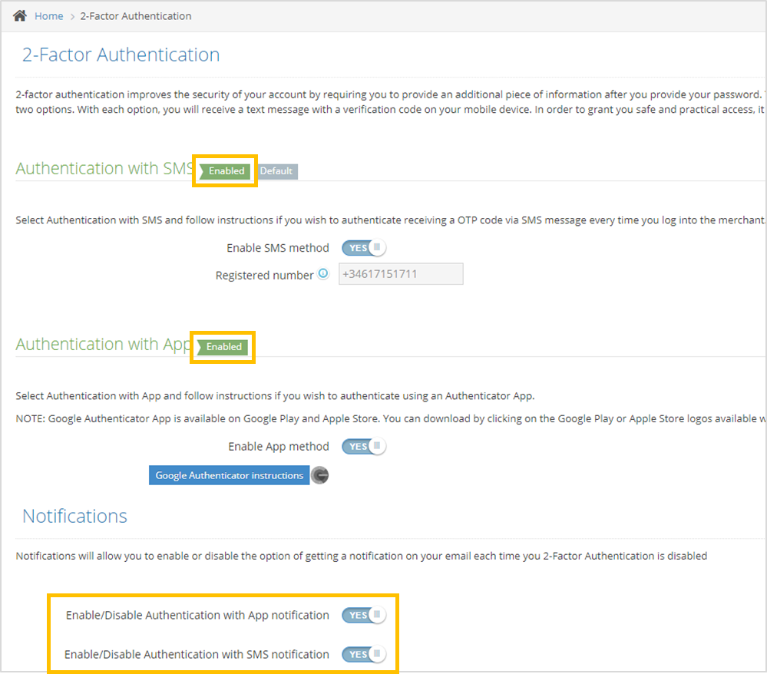

Disabling 2-Authentication methods

You can disable 2-Factor Authentication method by setting the toggle button to NO.

Disabling Authentication with SMS

Set toggle button to NO. A pop up will be displayed, click on Turn off.

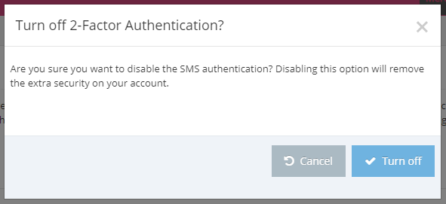

A code will be sent via SMS, enter the received code and click submit.

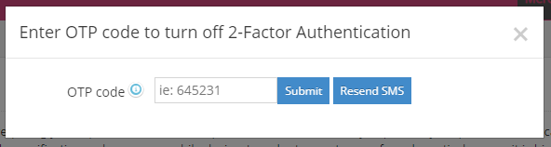

A message will confirm the method was successfully disabled.

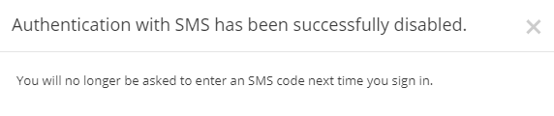

NOTE: Authentication with SMS toggle button will be set to NO and notifications for this method won´t appear in the Notifications section.

Disabling Authentication with App

Set toggle button to NO. A pop up will be displayed, click on Turn off.

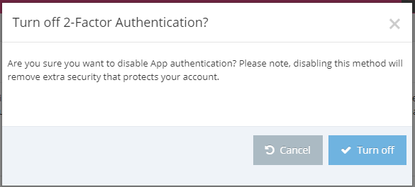

Open your Authentication App, enter the code and click submit.

A message will confirm the method was successfully disabled.

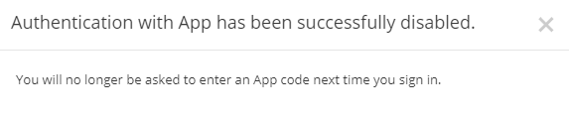

NOTE: Authentication with App toggle button will be set to NO and notifications for this method won´t appear in the Notifications section.

IMPORTANT INFORMATION:
- Sessions last for 3 minutes after logging out, during this time you won´t be asked to enter a new code. If 3 minutes have passed, you will need to enter a new code to be able to access your account again.

- When enabling Authentication with App again, you will need to re-read the QR code as it changes every time the method is enabled.

Problems signing in? Cannot authenticate option

If you have a problem logging in, please contact your Scalefast Account Manager to request for an emergency code.
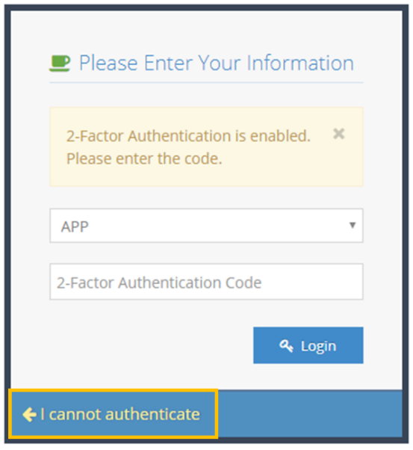

Once you receive the emergency code from your Account manager click on Back to login.

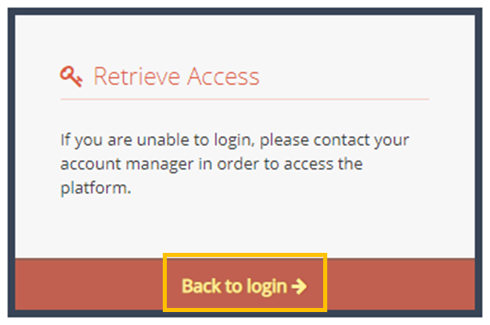

Enter the emergency code and click on login. Please note that emergency codes last for 2 minutes, if this time has passed, please contact your Account Manager an request a new one.

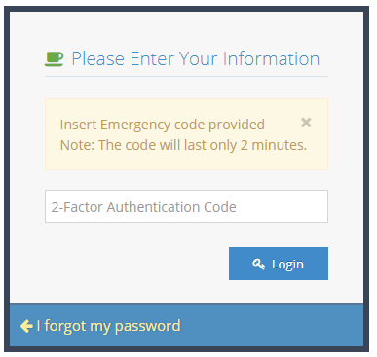

IMPORTANT INFORMATION

When using an emergency code 2 – Factor Authentication will be disabled. You will need to enable the feature again following the previous steps.

